ST. XAVIER'S COLLEGE

(Affiliated to Tribhuvan University)

Maitighar, Kathmandu



**Computer Graphics**

**Calculator**

**SUBMITTED BY:**

Sneha Prasai

013BSCCSIT040

**SUBMITTED TO**

Er. Anil Sah

( Lecturer )

Department of Computer Science

**STATEMENT:**

Design a simple calculator

**SOURCE CODE:**

//---------------------------------------------------------------------------

#include <vcl\vcl.h>

#pragma hdrstop

#include "Unit1.h"

//---------------------------------------------------------------------------

#pragma resource "*.dfm"

TForm1 *Form1;

int oflag,click,store,pstore,addflag,minflag,maxflag,divflag=0;

//---------------------------------------------------------------------------

__fastcall TForm1::TForm1(TComponent* Owner)

: TForm(Owner)

{

}

//---------------------------------------------------------------------------

void __fastcall TForm1::Button1Click(TObject *Sender)

{

if (oflag==1){

store=pstore;

oflag=0;

pstore=0;

}

click=1;

store=store*10+click;

Edit1->Text=store;

}

//---------------------------------------------------------------------------

void __fastcall TForm1::Button2Click(TObject *Sender)

{

oflag=0;

pstore=pstore+store;

click=0;

store=0;

addflag=1;

Edit1->Text="+";

}

//---------------------------------------------------------------------------

void __fastcall TForm1::Button3Click(TObject *Sender)

{

if (addflag==1){

pstore=pstore+store;

}

if (minflag==1){

pstore=pstore-store;

}

if (maxflag==1){

pstore=pstore*store;

}

if (divflag==1){

pstore=pstore/store;

}

addflag=0;

minflag=0;

maxflag=0;

divflag=0;

Edit1->Text=pstore;

store=0;

oflag=1;

}

//---------------------------------------------------------------------------

void __fastcall TForm1::Button4Click(TObject *Sender)

{

if (oflag==1){

store=pstore;

oflag=0;

pstore=0;

}

click=2;

store=store*10+click;

Edit1->Text=store;

}

//---------------------------------------------------------------------------

void __fastcall TForm1::Button5Click(TObject *Sender)

{

if (oflag==1){

store=pstore;

oflag=0;

pstore=0;

}

click=3;

store=store*10+click;

Edit1->Text=store;

}

//---------------------------------------------------------------------------

void __fastcall TForm1::Button6Click(TObject *Sender)

{

if (oflag==1){

store=pstore;

oflag=0;

pstore=0;

}

click=4;

store=store*10+click;

Edit1->Text=store;

}

//---------------------------------------------------------------------------

void __fastcall TForm1::Button7Click(TObject *Sender)

{

if (oflag==1){

store=pstore;

oflag=0;

pstore=0;

}

click=5;

store=store*10+click;

Edit1->Text=store;

}

//---------------------------------------------------------------------------

void __fastcall TForm1::Button8Click(TObject *Sender)

{

if (oflag==1){

store=pstore;

oflag=0;

pstore=0;

}

click=6;

store=store*10+click;

Edit1->Text=store;

}

//---------------------------------------------------------------------------

void __fastcall TForm1::Button9Click(TObject *Sender)

{

if (oflag==1){

store=pstore;

oflag=0;

pstore=0;

}

click=7;

store=store*10+click;

Edit1->Text=store;

}

//---------------------------------------------------------------------------

void __fastcall TForm1::Button10Click(TObject *Sender)

{

if (oflag==1){

store=pstore;

oflag=0;

pstore=0;

}

click=8;

store=store*10+click;

Edit1->Text=store;

}

//---------------------------------------------------------------------------

void __fastcall TForm1::Button11Click(TObject *Sender)

{

if (oflag==1){

store=pstore;

oflag=0;

pstore=0;

}

click=9;

store=store*10+click;

Edit1->Text=store;

}

//---------------------------------------------------------------------------

void __fastcall TForm1::Button12Click(TObject *Sender)

{

if (oflag==1){

store=pstore;

oflag=0;

pstore=0;

}

click=0;

store=store*10+click;

Edit1->Text=store;

}

//---------------------------------------------------------------------------

void __fastcall TForm1::Button13Click(TObject *Sender)

{

oflag=0;

pstore=pstore+store;

click=0;

store=0;

minflag=1;

Edit1->Text="-";

}

//---------------------------------------------------------------------------

void __fastcall TForm1::Button14Click(TObject *Sender)

{

oflag=0;

pstore=pstore+store;

click=0;

store=0;

maxflag=1;

Edit1->Text="*";

}

//---------------------------------------------------------------------------

void __fastcall TForm1::Button15Click(TObject *Sender)

{

oflag=0;

pstore=pstore+store;

click=0;

store=0;

divflag=1;

Edit1->Text="/";

}

//---------------------------------------------------------------------------

void __fastcall TForm1::Button16Click(TObject *Sender)

{

oflag=0;

click=0;

store=0;

pstore=0;

addflag=0;

minflag=0;

maxflag=0;

divflag=0;

Edit1->Text=0;

}

//---------------------------------------------------------------------------

OUTPUT:

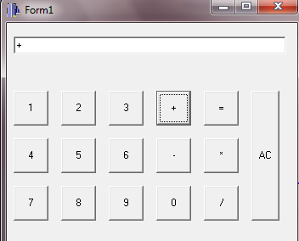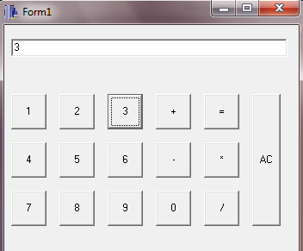

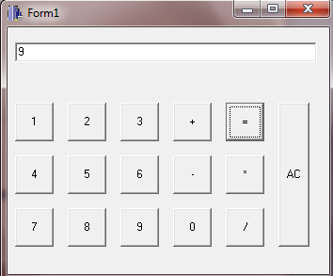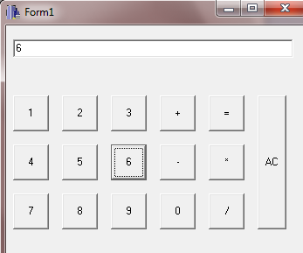

**CONCLUSION:**

The C++builder is used to design a simple calculator which performs the operations like add, subtract, multiply and divide.